



Dubmire Aim High Academy

Britannia Terrace

Fence Houses

Houghton le Spring  
Tyne & Wear

DH4 6HL

[Tel: 0191](Tel:0191) 5005958

Head teacher – Miss E Jarvis

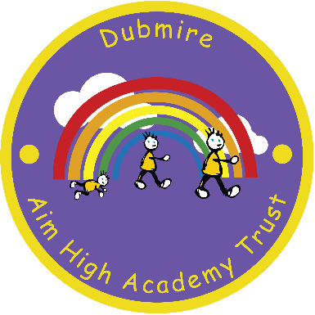

9th November 2017

Dear Parent / Carer

This Christmas we have arranged a treat for all KS1, Reception and Nursery children who have shown excellent attitudes in class and have followed class and school rules.

The treat for pupils this year will be a visit from M&M Theatrical Productions who will perform their fabulous Snow White pantomime on the morning of Thursday 12th December 2019.

Although the cost has been heavily subsidised, to enable us to provide this treat for pupils and help cover the cost of the production, we would be extremely grateful if you would make a donation of £3.50 per pupil.

Would you please return your contribution and the completed slip below no later than **Monday 2nd December 2019**

Yours faithfully

E Jarvis

E Jarvis

Head Teacher

______________________________________________________________________________

**KS1 / Reception Christmas Pantomime**

I enclose £3.50 contribution towards the KS1 / Reception / Nursery Christmas pantomime, Snow White for my child

…………………………………………………………………………………………………. Class ………………………………….

Signed Parent / Carer…………………………………………………… ……………Date………………..…..…………….