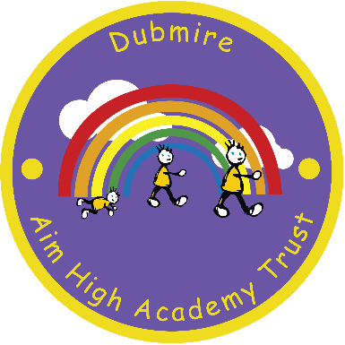
Dubmire Aim High Academy
Britannia Terrace
Fence Houses
Houghton le Spring
Tyne & Wear
DH4 6HL

Tel: 0191 3823071 – Fax 0191 3823072
Head teacher – Miss E Jarvis

5th February 2020

Dear Parent/Carer,

Educational Visit to Durham Cathedral

As part of their Curriculum, Year 2 pupils will be going on an outing to enhance their RE Units, learning about the life of Bede and life as a monk. They will be visiting Durham Cathedral on Tuesday 25th February 2020. We would appreciate a contribution of £8 to help towards the cost of the coach hire / entry fee for your child.

The party will leave school at 9.15am and will return to school by approximately 13:30pm. A packed lunch will be needed on the day. As your child qualifies for free school meals, would you please indicate below if you would like school to provide a packed lunch or if you would prefer to provide your own. (If sending a packed lunch from home, please use a throw away bag rather than a packed lunch box. Also please do not include fizzy/energy drinks or glass bottles)

Children should wear their full school uniform as usual but please make sure they have a warm coat. A maximum of £2 spending money can be taken to spend at the cathedral shop.

Please complete the permission slip and return together with the payment of £8 before Wednesday 12th February 2020.

Yours faithfully,

E Jarvis

Miss E Jarvis
Head Teacher

Y2 Durham Cathedral

I give permission for my child ………………………………………………………………………….…Class.…………………………
to visit Durham Cathedral on Tuesday 25th February 2020 and enclose contribution of £8.00

I would like a school packed Lunch be provided
I will provide a packed lunch from home

Signature of parent/carer ………………………………………………………………………..………Date…………………………

