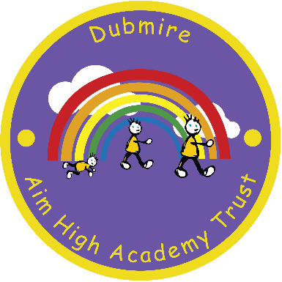
Dubmire Aim High Academy
Britannia Terrace
Fence Houses
Houghton le Spring
Tyne & Wear
DH4 6HL

Tel: 0191 5005958
Head teacher – Miss E Jarvis

10th February 2020

Dear Parent / Carer
The school meals service will be hosting a special themed day to celebrate World Book Day on Thursday 5th March. The menu will be:
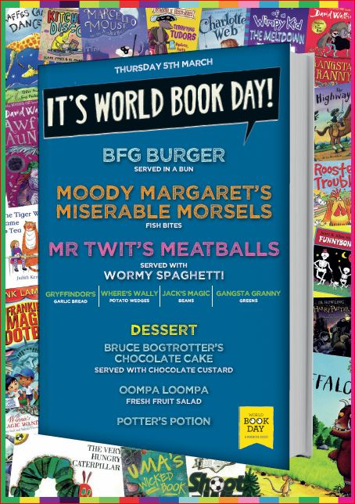

BFG Burger served in a bun
Moody Margaret’s Miserable Morsels (Fish Bites)
Mr Twit’s Meatball’s served with wormy spaghetti
with the following side dishes:
Gryffindor’s garlic bread, Where’s Wally potato wedges,
Jack’s magic beans and Gangsta granny greens

Followed by:
Bruce Bogtrotter’s chocolate cake with chocolate custard
Oompa Loompa fruit salad
Potter’s Potion

If your child usually has a packed lunch and would like to order a school meal for Thursday 5th March 2020, please return the slip below enclosed with £2.20 to the school office no later than Monday 24th February 2020 (if you qualify for free school meals please return the slip only) Children already on school dinners will automatically receive a World Book Day lunch.
Yours faithfully,
E Jarvis
Headteacher

My child ………………………………………………………………….………………………………………………………..……. Class………..……………..
would like a school meal on Thursday 5th March 2020 (please tick)
I enclose £2.20 I qualify for free school meals
Signed………………………………………………………………………………………………………………………………….Date……………………………….

